Setup for Samba on CentOS 7
Samba is an open-source software suite that runs on Unix/Linux based platforms but can communicate with Windows clients like a native application. So Samba is able to provide this service by employing the Common Internet File System (CIFS).
At the heart of this CIFS is the Server Message Block (SMB) protocol. Samba does this by performing these 4 key things –
- File & print services
- Authentication and Authorization
- Name resolution
- Service announcement (browsing)
Samba can be run on many different platforms including Linux, Unix, OpenVMS and operating systems other than Windows and allows the user to interact with a Windows client or server natively. It can basically be described as the Standard Windows interoperability suite of programs for Linux and Unix.
Note that we will create two forms of Samba server, one setup won’t require a password to share files with any client on the network which is the anonymous share and another setup will require setting up users and permissions.
The main samba configuration file is /etc/samba/smb.conf

Linux PC – 192.168.8.11/24
Windows PC – 192.168.8.12/24

Install Samba4 in CentOS 7

1. First install Samba4 and required packages from the default CentOS repositories using the yum package manager tool as shown.
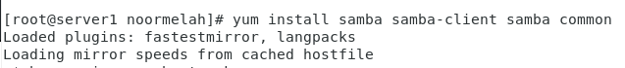

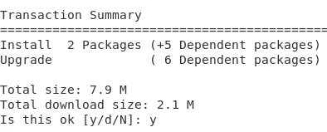

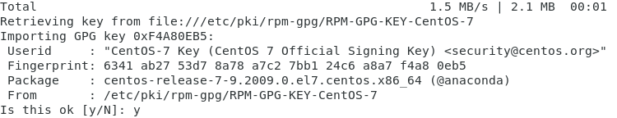

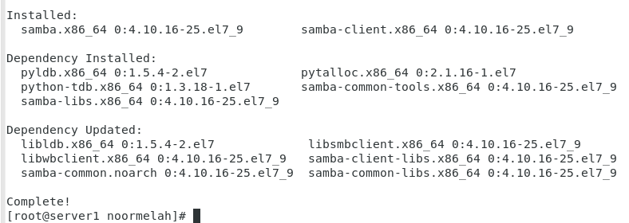

2. After installing the samba packages, enable samba services to be allowed through system firewall with these commands.

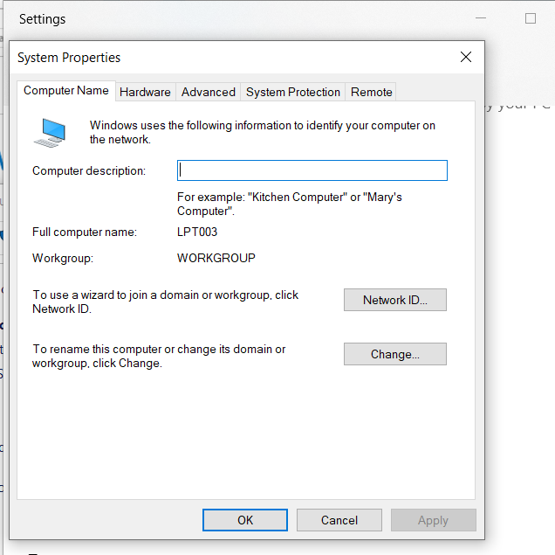

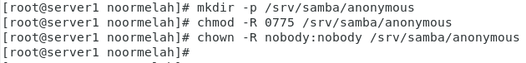

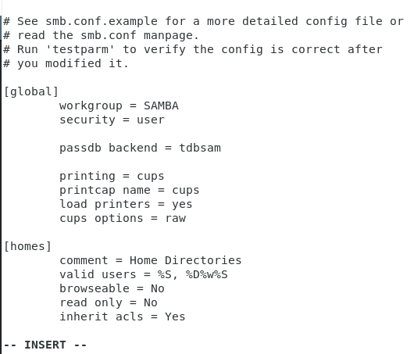

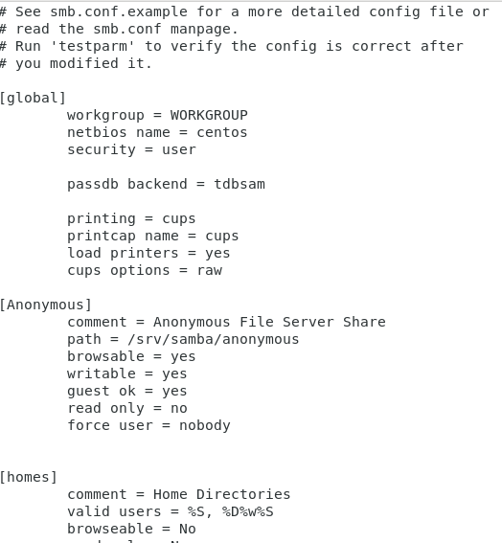

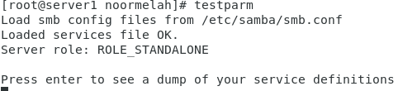

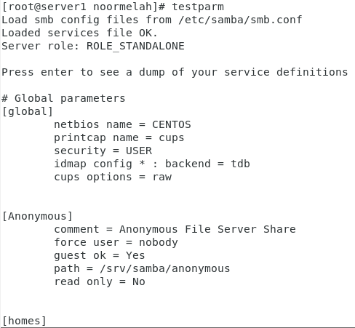

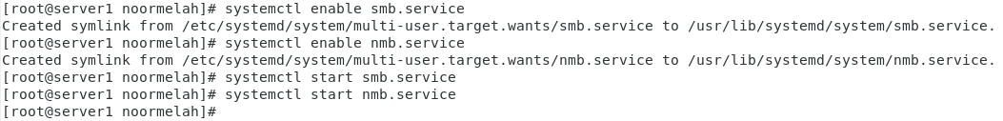

inet 192.168.206.132

